VISVESVARAYA TECHNOLOGICAL UNIVERSITY
“Jnana Sangama”, Belagavi– 590 018


A Project Report on
“MINI OSCILLOSCOPE”
Submitted in the partial fulfillment of the requirements for the award of degree of

BACHELOR DEGREE
IN
ELECTRICAL & ELECTRONICS ENGINEERING
Submitted by
Mr. ABHIJEET SAHUKAR USN : 2BL23EE001
Mr.ROHIT BHUJANGANAVAR USN:2BL23EE061
Mr. SHASHIDHAR PATTANASHETTI USN :2BL23EE071
Mr. SIDDAPPA SAJJAN USN : 2BL23EE079
Under the Guidance of

Prof. VINAY KOLLUR
B.L.D.E.A’s
V P Dr. P.G.Halakatti College of Engineering &Technology, Vijayapur-586103, Karnataka
Academic Year 2025-26

B.L.D.E.A’s
V P Dr. P.G.Halakatti College of Engineering &Technology, Vijayapur-586103, Karnataka

DEPARTMENT OF ELECTRICAL AND ELECTRONICS ENGINEERING


CERTIFICATE

This is to certify that Mr. Abhijeet Sahukar, Mr. Rohit Bhujanganavar, Mr. Shashidhar Pattanashetti, and Mr. Siddappa Sajjan are bonafide students of V. P. Dr. P. G. Halakatti College of Engineering & Technology, and have completed the project work entitled “MINI OSCILLOSCOPE” in partial fulfilment for the award of Bachelor Degree in Electrical & Electronics Engineering of the Visvesvaraya Technological University, Belagavi, during the year 2025–2026.It is certified that all corrections/suggestions indicated for Internal Assessment have been incorporated in the report deposited in the departmental library. The project report has been approved as it satisfies the academic requirements in respect of project work prescribed for the said degree.

Project Guide HOD Principal
Vinay Kollur Dr.A.S.Jadhav Prof. P. Manjunath
B.L.D.E.A’s
V P Dr. P.G.Halakatti College of Engineering &Technology, Vijayapur-586103, Karnataka

DEPARTMENT OF ELECTRICAL AND ELECTRONICS ENGINEERING


DECLARATION
We, Mr. Abhijeet Sahukar, Mr. Rohit Bhujanganavar, Mr. Shashidhar Pattanashetti, and Mr. Siddappa Sajjan, students of Fifth sem B.E., Electrical and Electronics Engineering, B.L.D.E.A’s V. P. Dr. P. G. Halakatti College of Engineering and Technology, hereby declare that the project work titled “MINI OSCILLOSCOPE” has been carried out by us and submitted in partial fulfillment of the course requirement for the award of the degree of Bachelor of Engineering in Electrical and Electronics Engineering of Visvesvaraya Technological University, Belagavi, during the academic year 2025–2026.
We also declare that we have not submitted this project report to any other university for the award of the degree.
STUDENT NAME USN
Mr. ABHIJEET SAHUKAR USN : 2BL23EE001 Mr.ROHIT BHUJANGANAVAR USN:2BL23EE061 Mr. SHASHIDHAR PATTANASHETTI USN :2BL23EE071 Mr. SIDDAPPA SAJJAN USN : 2BL23EE079

AKNOWLEDGEMENT
Everything we do should be a result of gratitude for what people has done for us
The satisfaction and euphoria that accompany the successful completion of any task would be incomplete without the mention of the people who made it possible and whose constant encouragement and guidance crowned our efforts with success. We express our sincere thanks to our beloved Principal, Prof. P. Manjunath, for extending his continuous support and for providing an excellent academic environment. We wish to thank our Head of the Department, Dr. A. S. Jadhav, for his encouragement and support throughout the course of this project. We express our heartfelt gratitude to our Project Guide, Dr. A. S. Jadhav, for his constant guidance, motivation, and valuable suggestions. His patience, support, and careful correction of our work helped us progress smoothly at every stage of the project. We are proud to be a part of the B.L.D.E.A’s CET family, the institution which stood behind the successful completion of our project. We owe our sincere thanks to all the faculty members of the Electrical and Electronics Engineering Department for their moral support, technical guidance, and encouragement.
We extend special thanks to our beloved parents and dear friends for their continuous encouragement, motivation, and blessings, without which we would not have reached this stage.
Lastly, we would like to thank all those who have directly or indirectly supported us in successfully carrying out this project.
STUDENT NAME USN
Mr. ABHIJEET SAHUKAR USN : 2BL23EE001 Mr.ROHIT BHUJANGANAVAR USN:2BL23EE061 Mr. SHASHIDHAR PATTANASHETTI USN :2BL23EE071 Mr. SIDDAPPA SAJJAN USN : 2BL23EE079

ABSTRACT
Electronic measurement instruments are essential tools in the field of Electrical and Electronics Engineering. Among these instruments, the oscilloscope plays a crucial role in observing and analyzing electrical signal waveforms such as voltage variations with respect to time. Oscilloscopes are widely used in laboratories and educational institutions for testing and analyzing electronic circuits. However, conventional oscilloscopes are expensive, bulky, and not easily accessible in many educational institutions, especially in rural and small laboratory setups.
Due to the high cost and limited availability of commercial oscilloscopes, students often face difficulties in understanding real-time signal behavior during practical experiments. Therefore, there is a need for a compact, affordable, and easy-to-use oscilloscope that can serve basic measurement and educational purposes.
To overcome these challenges, this project focuses on the development of a Mini Oscilloscope using a microcontroller-based system. The proposed system is designed to measure and display electrical signal waveforms in real time using a simple and cost-effective approach. An Arduino UNO is used as the core controller to sample analog input signals from electronic circuits and convert them into digital data using its built-in Analog-to-Digital Converter (ADC).
The processed digital data is displayed on a 0.96-inch OLED display, allowing users to clearly observe waveform shape, amplitude variations, and signal behavior. Features such as adjustable sensitivity and stable waveform display make the system suitable for basic signal analysis and educational use.
The mini oscilloscope is portable, economical, and energy efficient, making it ideal for academic laboratories and basic electronics applications. By combining signal acquisition, microcontroller processing, and real-time waveform visualization, the project promotes hands-on learning and practical understanding of electronics.
LIST OF CONTENTS
CONTENT PAGE NO.
1.INTRODUCTION_ _ _ _ _ _ _ _ _ _ _ _ _ _ _ _ _ _ _ _ _ _ _ _ _ _ _ _ _ _ _01
2.LITERATURE REVIEW_ _ _ _ _ _ _ _ _ _ _ _ _ _ _ _ _ _ _ _ _ _ _ _ _ _ _ _ 02
3.DESIGN METHODOLOGY
3.1 Introduction_ _ _ _ _ _ _ _ _ _ _ _ _ _ _ _ _ _ _ _ _ _ _ _ _ _ _ _ _ _ _ _ _ _
3.2. Planning_ _ _ _ _ _ _ _ _ _ _ _ _ _ _ _ _ _ _ _ _ _ _ _ _ _ _ _ _ _ _ _ _ _ _ _
3.3 Analysing _ _ _ _ _ _ _ _ _ _ _ _ _ _ _ _ _ _ _ _ _ _ _ _ _ _ _ _ _ _ _ _ _ _ _
3.4 Design_ _ _ _ _ _ _ _ _ _ _ _ _ _ _ _ _ _ _ _ _ _ _ _ _ _ _ _ _ _ _ _ _ _ _ _ _
4. HARDWARE DESCRIPTION
4.1 Arduino _ _ _ _ _ _ _ _ _ _ _ _ _ _ _ _ _ _ _ _ _ _ _ _ _ _ _ _ _ _ _ _ _ _ _ _
4.2 OLED Display_ _ _ _ _ _ _ _ _ _ _ _ _ _ _ _ _ _ _ _ _ _ _ _ _ _ _ _ _ _ _ _ _
4.3 Breadboard_ _ _ _ _ _ _ _ _ _ _ _ _ _ _ _ _ _ _ _ _ _ _ _ _ _ _ _ _ _ _ _
4.4 Jumper _ _ _ _ _ _ _ _ _ _ _ _ _ _ _ _ _ _ _ _ _ _ _ _ _ _ _ _ _ _ _ _
4.5 Wires Resistance_ _ _ _ _ _ _ _ _ _ _ _ _ _ _ _ _ _ _ _ _ _ _ _ _ _ _ _ _ _ _ _
4.6 Diode_ _ _ _ _ _ _ _ _ _ _ _ _ _ _ _ _ _ _ _ _ _ _ _ _ _ _ _ _ _ _ _
4.7 Capacitor_ _ _ _ _ _ _ _ _ _ _ _ _ _ _ _ _ _ _ _ _ _ _ _ _ _ _ _ _ _ _ _
4.8 Transistor_ _ _ _ _ _ _ _ _ _ _ _ _ _ _ _ _ _ _ _ _ _ _ _ _ _ _ _ _ _ _ _

5. SYSTEM DEVELOPMENT AND ANALYSIS
5.1 System Architecture_ _ _ _ _ _ _ _ _ _ _ _ _ _ _ _ _ _ _ _ _ _ _ _ _ _
5.2 Circuit _ _ _ _ _ _ _ _ _ _ _ _ _ _ _ _ _ _ _ _ _ _ _ _ _ _
5.3 Working _ _ _ _ _ _ _ _ _ _ _ _ _ _ _ _ _ _ _ _ _ _ _ _ _ _
5.4 Software used_ _ _ _ _ _ _ _ _ _ _ _ _ _ _ _ _ _ _ _ _ _ _ _ _ _

6. ADVANTAGES AND DISADVANTAGES
6.1 ADVANTAGES_ _ _ _ _ _ _ _ _ _ _ _ _ _ _ _ _ _ _ _ _ _ _ _ _ _
6.2 DISADVANTAGES _ _ _ _ _ _ _ _ _ _ _ _ _ _ _ _ _ _ _ _ _ _ _ _ _ _

7. APPLICATION_ _ _ _ _ _ _ _ _ _ _ _ _ _ _ _ _ _ _ _ _ _ _ _ _ _
8. RESULT AND DISCUSSION_ _ _ _ _ _ _ _ _ _ _ _ _ _ _ _ _ _ _ _ _ _ _ _ _
9. CONCLUSION _ _ _ _ _ _ _ _ _ _ _ _ _ _ _ _ _ _ _ _ _ _ _ _ _ _
*References

LIST OF FIGURES
FIGURE NO | TITLE | PG NO
01 | Block Diagram of Smart Irrigation System Using Esp32 | 04
02 | Esp32 Node MCU 32S | 07
03 | DHT22 Humidity and Temperature Sensor | 09
04 | Soil Moisture Sensor | 10
05 | 12v DC Mini Submersible Pump | 11
06 | 5v 1 Channel Relay Module | 12
07 | 12v Power Adapter | 14
08 | LM2596 Buck Converter | 14
09 | Breadboard | 14
10 | Block Diagram of a System Architecture | 15
11 | Circuit Diagram of The Model | 15
12 | Complete Working Model of Hardware Setup of Smart Irrigation System | 25
13 | Firebase Realtime Database Structure for Crop Thresholds and Sensor Logs | 25
14 | Blynk IOT App Interface | 26
15 | Mobile App Interface – Home | 26FF
16 | QR Generator Interface -Crop Name and Threshold with Downloadable QR | 26
17 | Downloadable QR Code | 27
18 | QR App Interface – Scan and Send Crop Threshold to Firebase | 27

CHAPTER-1

1.1 INTRODUCTION
Electronics and instrumentation form the backbone of all modern electrical and electronic systems. Whether in communication engineering, embedded systems, power electronics, or biomedical instrumentation, the ability to observe, understand, and analyze electrical signals is essential. Among the various instruments used for this purpose, the oscilloscope stands out as one of the most powerful tools. It allows users to visualize waveform characteristics such as amplitude, frequency, phase, periodicity, and signal distortions. Engineers and students use oscilloscopes to test circuits, diagnose faults, and validate designs. Despite their importance, professional digital storage oscilloscopes (DSOs) are often expensive and bulky, making them difficult to access for beginners, hobbyists, and small educational institutions with limited resources.
To address this accessibility problem, the development of a Mini Oscilloscope using Arduino and OLED Display provides an innovative, low-cost, and portable alternative. This project leverages the simplicity and versatility of the Arduino platform along with a compact OLED display to replicate the basic functionality of an oscilloscope. While it may not match the high-speed sampling rates or advanced triggering features of commercial DSOs, it effectively demonstrates real-time waveform visualization at a fraction of the cost. The mini oscilloscope is particularly useful for academic learning, DIY electronics, prototype testing, and demonstrations where high precision is not mandatory.
The core idea behind this project is to convert analog electrical signals into digital values using the Arduino’s built-in Analog-to-Digital Converter (ADC) and then plot these values on a small OLED display. This provides students with practical exposure to concepts such as analog sampling, digital conversion, display interfacing, and signal processing fundamentals. Additionally, the compact size and simple design make the device highly portable, enabling students to carry it anywhere for quick circuit testing or demonstration purposes.
Another major advantage of this project is its affordability. Arduino boards and OLED screens are widely available, inexpensive, and easy to interface. By using minimal external components, the total cost remains low while still providing valuable functionality. This democratizes access to basic test equipment and encourages students to explore electronics more independently.
Moreover, the project fosters a deeper understanding of instrumentation principles. Students learn how sampling rate affects waveform accuracy, how signal scaling is performed, and how memory buffers are used to store and update data points. By programming the oscilloscope logic themselves, they also gain insight into how commercial oscilloscopes operate internally, including their triggering mechanisms and display refresh processes.

1.2 OBJECTIVE
The main objectives of this project are:
1. To develop an economical mini oscilloscope that can be built using easily available components.
2. To analyze low-frequency analog signals typically generated in student-level electronic experiments.
3. To implement real-time signal sampling with stable and accurate data capture.
4. To design a compact system that combines signal acquisition, processing, and display in one unit.
5. To understand and apply ADC principles such as sampling rate, resolution, and quantization.
6. To convert the acquired analog signals into digital data for processing through Arduino.
7. To create a graphical waveform plot representing electrical signals on a small OLED screen.
8. To ensure smooth refresh rate so that waveforms appear continuous and readable.
9. To minimize power consumption making the device suitable for USB or battery operation.
10. To study communication protocols (I2C/SPI) used for microcontroller-to-display interfacing.
11. To practice embedded C/C++ programming for microcontroller-based visualization.
12. To understand the limitations of low-cost oscilloscopes and compare them with professional DSOs.
13. To provide a teaching tool for basic electronics, especially in labs with limited instruments.
14. To test small electronic circuits, sensors, and microcontroller outputs using the developed oscilloscope.
15. To enhance practical knowledge in instrumentation engineering through hands-on project work.
16. To encourage innovation and DIY learning by building a functional measurement device.
17. To improve understanding of waveforms such as sine, square, and triangular waves.
18. To develop debugging skills for real-time electronics troubleshooting using a simple portable tool.

CHAPTER-2

2.1 METHODOLOGY

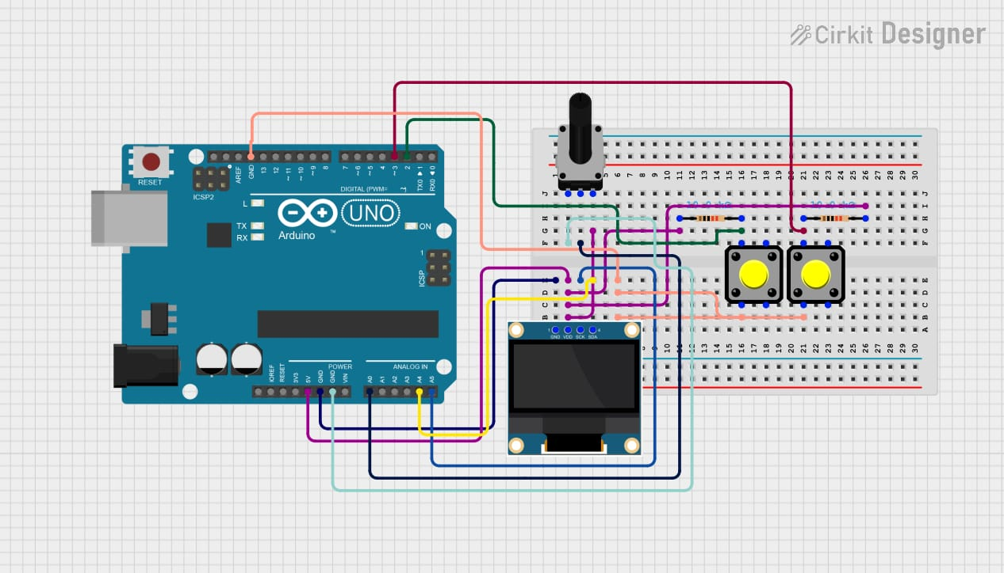
Figure 2.1: Circuit Diagram

1. Analog-to-Digital Conversion (ADC)
The Arduino UNO uses its 10-bit ADC to convert the analog input signal (0–5V) into digital values. These digital samples represent the waveform and are used to plot the signal on the display.

2. Real-Time Signal Sampling
The Arduino continuously samples the input voltage from the potentiometer (or any analog source). By capturing many samples per second, it reconstructs the time-varying waveform similar to a real oscilloscope.

3. I²C Display Visualization
The OLED screen communicates with the Arduino using the I²C protocol (SDA & SCL). The sampled waveform points are sent to the OLED and displayed graphically, allowing real-time visualization of the signal.

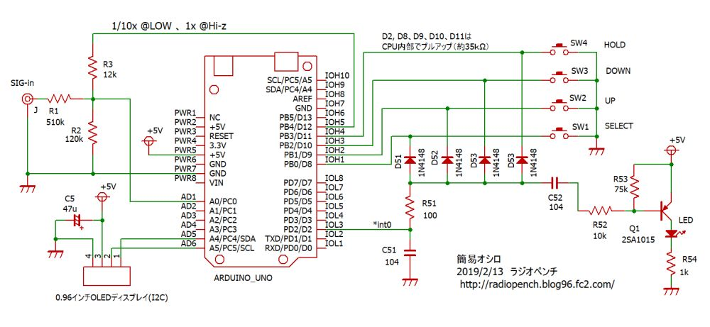
Figure 2.2: Block Diagram
Explanation of Block Diagram
1. Input Signal
- The electrical signal to be analyzed (sine, square, PWM, etc.)
- Voltage range must be safe for Arduino (0–5V).
2. Signal Conditioning
- Adjusts and protects the input signal.
- Includes resistors, voltage divider, and optional filtering.
- Ensures signal stays in safe range for ADC.
3. Arduino (Microcontroller Unit)
- Reads signal using the Analog-to-Digital Converter (ADC).
- Samples and converts analog voltage into digital values.
- Processes data to create waveform points.
- Sends processed data to the OLED display.
4. OLED Display
- Displays real-time waveform.
- Provides high contrast, low-power graphical output.

CHAPTER-3
HARDWARE REQUIREMENT:
3.1 Arduino UNO
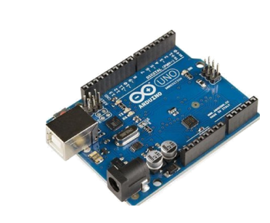
Figure:3.1 Arduino UNO
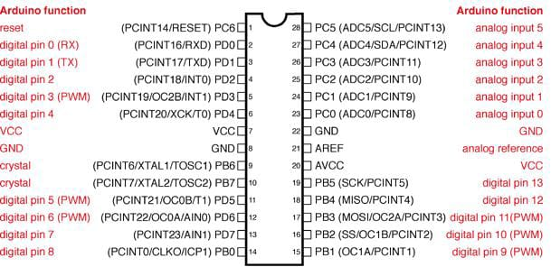
Figure: 3.2 Arduino IC Pin Diagram

Arduino UNO is a microcontroller board based on the Atmega328P. It has 14 digital input/output pins, 6 analog inputs, a 16 MHz ceramic resonator, a USB connection, a power jack, an ICSP header and a reset button.
Digital Pins: There are 14 digital pins on Arduino Uno which can be connected to components like LED, LCD, etc.
Analog Pins: There are 6 analog pins on the Uno. These pins are generally used to connect sensors because all the sensors generally have analog values. Most of the input components are connected here.
Power Supply: The power supply pins are IOREF, GND, 3.3V, 5V, Vin and are used for connecting sensors because all the sensors generally have analog values. Most of the input components are connected here.
Power Jack: Uno board can be powered both by external supply and via USB cable.

USB Port: This port function is to program the board or to upload the program. The program can be uploaded to the board with the help of Arduino IDE and USB cable.
Reset Button: This is used to restart the uploaded program.

3.2 OLED Display
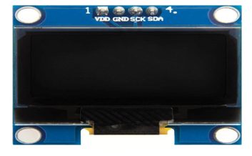
Figure 3.3: OLED Display

1. High Contrast & Clear Display
OLED displays produce their own light (no backlight), giving sharp, bright, and high-contrast visuals, which makes waveform viewing easy and clear.

2. I²C Communication (Two-Wire Interface)
The OLED works using the I²C protocol with only SDA and SCL pins, reducing wiring complexity and allowing fast data transfer for real-time waveform display.

3. Low Power & Compatible with Arduino
The OLED operates on 3.3V–5V, consumes very little power, and is directly compatible with Arduino, making it ideal for portable and battery-powered projects.

3.3 Breadboard
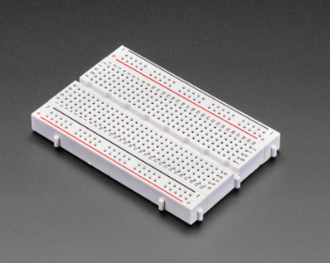
Figure 3.4: Breadbord

- Used for circuit prototyping
  - Allows building circuits without soldering, making it easy to modify or troubleshoot.
- Provides power distribution rails
  - The side rails supply 5V and GND to all components efficiently.
- Helps connect components easily
  - The internal conductive strips allow components, wires, and modules to be interconnected quickly and neatly.
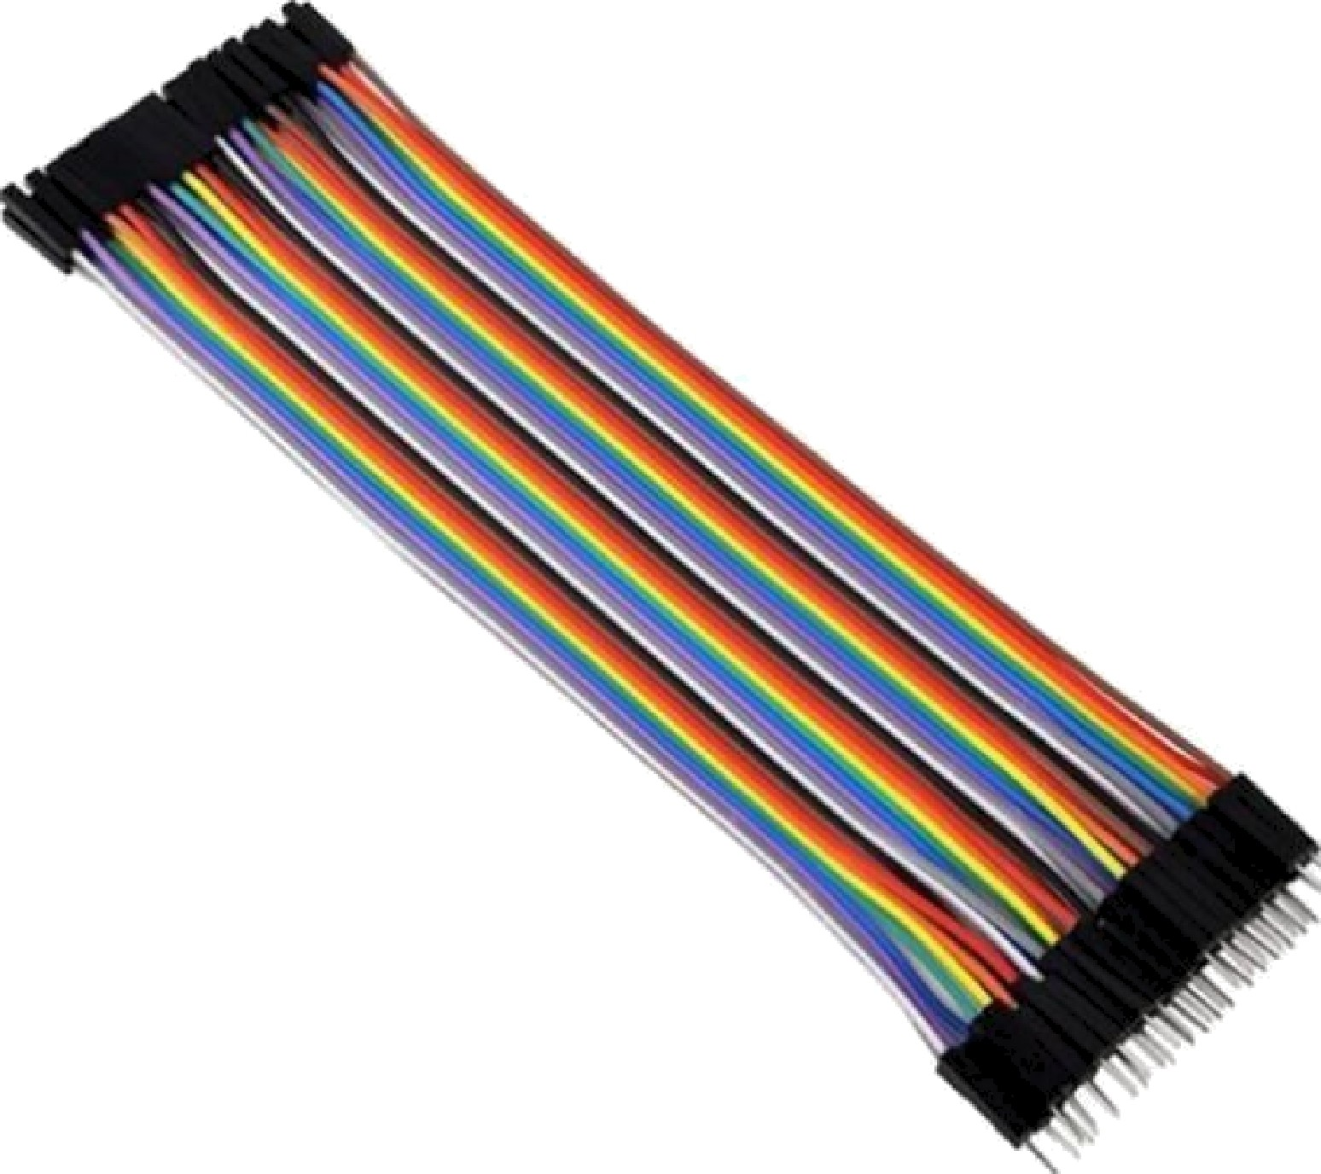
3.4 Jumper Wires:

Figure 3.5: Jumper Wires

1. Used to connect different components such as microcontrollers, sensors, and modules during prototyping.
2. Available in various lengths and types (male–male, male–female, female–female) for flexible circuit connections.
Help build circuits on a breadboard without soldering, making construction easy and reusable.
3.5 Resistance:
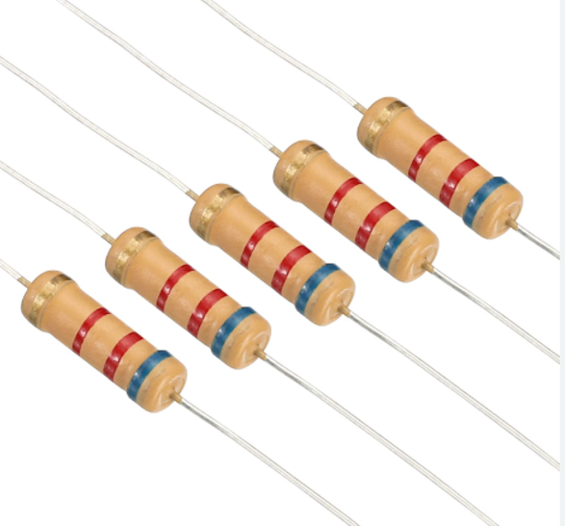
Figure 3.6: Resistance
1. Input Signal Attenuation Network (R1, R2, R3)
Resistors R1 (510 kΩ), R2 (120 kΩ), and R3 (12 kΩ) form a voltage divider used to scale down the incoming signal (SIG-in).
This protects the Arduino analog input from high voltages and ensures measurable signal levels.

2. Provides Switchable Probe Attenuation (1× / 10×)
These resistors help achieve 1× or 10× attenuation, enabling the oscilloscope to handle signals of different amplitudes without distortion or overvoltage.

3. Input Impedance Stabilization
The high-value resistor (e.g., R1 = 510 kΩ) ensures high input impedance, reducing loading effects on the signal source — essential for accurate waveform reading.

4. Noise Filtering with RC Combination
Together with capacitor C5, the divider resistors form an RC low-pass filter, reducing high-frequency noise and stabilizing the sampled waveform.

5. LED Current Limiting (R54 – 1 kΩ & R52/R53)
Resistor R54 (1 kΩ) limits current through the LED, preventing damage.
Resistors R52 (10 kΩ) and R53 (75 kΩ) work with transistor Q1 to set appropriate LED drive current during status indication.

7. Button Debouncing & Pull-up Interaction
The circuit uses internal pull-ups, but resistors such as R51 (100 Ω) and diodes help smooth transitions, ensuring clean logic levels when UP, DOWN, SELECT, HOLD buttons are pressed.

8. Voltage Reference and Biasing
Some resistors provide stable bias voltages and protect reference lines for the ADC, ensuring proper scaling and accurate analog measurements.

3.6 Diode:

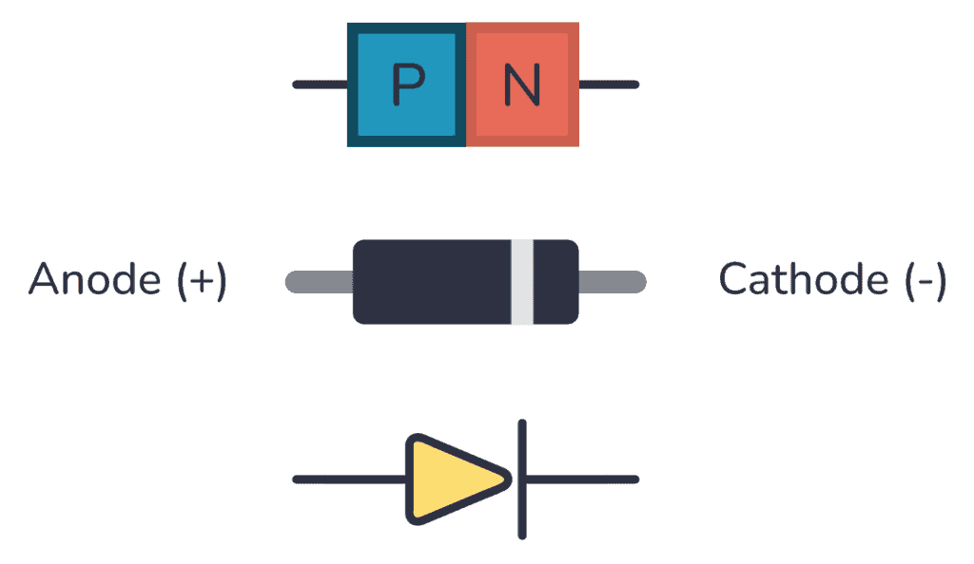
Figure 3.7: Diode
- The circuit uses high-speed switching diodes of type 1N4148, which are commonly employed in digital and signal-processing circuits due to their fast response time.
- These diodes are placed in series with the push-button switches (SW1–SW4) to provide isolation between different control lines connected to the Arduino microcontroller.
- The main purpose of the diodes is to prevent reverse current flow, ensuring that pressing one switch does not unintentionally activate or influence other switches in the circuit.
- They protect the Arduino input pins from unintended voltage overlaps, which may occur during rapid button transitions or due to floating inputs.
- 1N4148 diodes allow only one-way current conduction, thereby acting as logic-direction controllers for the user interface buttons.
- Their fast switching characteristic enables smooth and accurate reading of button presses without causing delays in the oscilloscope’s menu navigation.
- The diodes contribute to signal shaping and noise reduction, ensuring clean transitions for digital input detection by the microcontroller.
- They help implement a diode-matrix configuration, allowing multiple buttons to share Arduino pins while avoiding key-press conflicts or ghosting effects.

3.7 Capacitor:
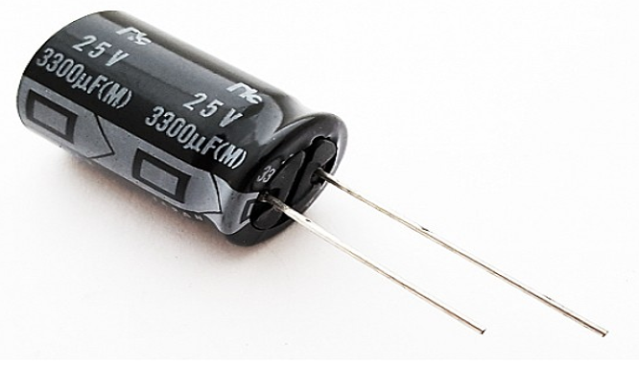
Figure 3.8: Capacitor
• Capacitors in the circuit are used mainly for signal filtering and voltage stabilization.
• They smooth out noise from the input signal, giving a cleaner waveform to the Arduino ADC.
• The electrolytic capacitor reduces high-frequency disturbances and prevents sudden voltage spikes.
• Capacitors help maintain stable power to the OLED display and control section.
• They improve the overall accuracy of the oscilloscope by reducing ripple and unwanted variations.
• In the input network, the capacitor forms a low-pass filter, protecting the microcontroller.
• Capacitors also help in debouncing switch signals, ensuring stable button readings.

3.8 Transistor:
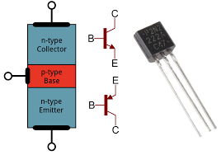

Figure 3.9: Transistor
- A transistor (PNP type like 2SA1015) is used as a driver in the circuit.
- It controls the indicator LED without overloading the Arduino output pins.
- The transistor acts as a switching device, turning the LED ON/OFF based on control signals.
- It provides current amplification, enabling higher current loads than the Arduino alone can handle.
- The biasing resistors ensure the transistor operates safely in switching mode.
- It protects the Arduino by isolating it from higher current paths.
- The transistor improves overall reliability by preventing direct current surges to the microcontroller.
- It enhances user feedback by giving a visible LED indication when the circuit is active.

CHAPTER -4
4.1 Result:
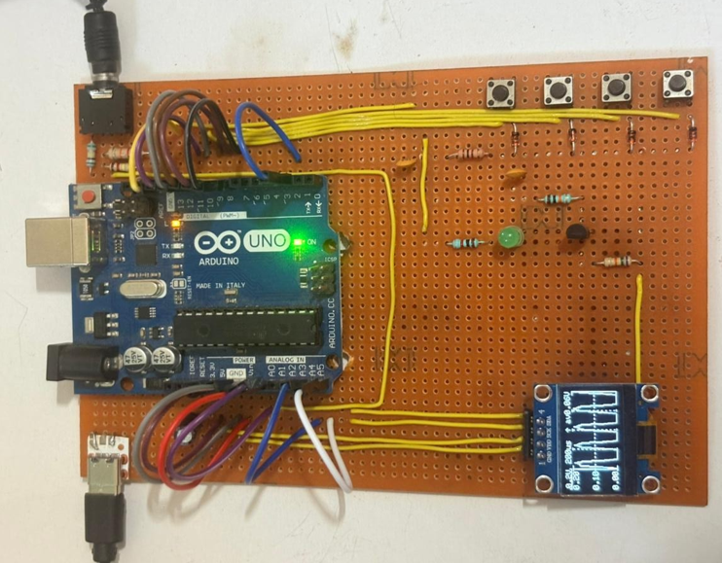
Figure 4.1: Prototype of Mini Oscilloscope
1. Arduino Uno as Main Controller
- The Arduino Uno (ATmega328P) functions as the central processing unit, performing ADC sampling, waveform reconstruction, user-input handling, and communication with the OLED display.
2. 0.96-inch OLED Display for Waveform Visualization
- A compact SSD1306 OLED display is used to present the waveform in real time, offering high contrast, low power consumption, and quick refresh for clear graphical output.
3. Input Signal Conditioning Network
- A combination of resistors and capacitors forms a voltage divider and filter circuit, ensuring that the incoming analog signal is safely scaled before reaching the Arduino’s A0 pin.
4. Four Pushbuttons for User Interface
- Four tactile switches (UP, DOWN, SELECT, HOLD) are mounted on the board to provide menu navigation, sensitivity adjustment, and waveform freeze control.
5. Diodes for Button Isolation
- Small-signal diodes (1N4148) are connected in series with each pushbutton to prevent reverse current flow and avoid switch ghosting or accidental multi-key triggering.
6. Transistor and LED Driver Section
- A PNP transistor (2SA1015 or equivalent) with associated resistors drives an indicator LED, providing visual feedback and protecting the Arduino from excessive current.
7. Stable Power Supply Arrangement
- The circuit is powered through USB or DC jack, using the Arduino’s built-in voltage regulator to supply +5V to all components including the OLED, switches, and transistor circuit.
8. Organized Wiring for Clear Signal Separation
- Different colored wires are used for signal lines, power lines, I2C communication, and button connections, ensuring clean layout and minimizing noise in ADC readings.
9. Compact and Durable PCB Construction
- The entire design is built on a general-purpose perforated PCB (veroboard), making the system rigid, portable, and suitable for laboratory experiments and academic demonstrations.
10. LED Indicator for System Activity
- A dedicated LED provides real-time activity indication, helping the user understand the system status and functionality during waveform capture.

11. Practical Arrangement for Easy Troubleshooting
- Components are spaced and oriented properly to facilitate quick testing, maintenance, and modification during project development.

Conclusion:
A mini oscilloscope is an electronic instrument used to display and analyze electrical signals in the form of waveforms. In this project, an Arduino Uno is used as the main controller, which reads the input signal through its 10-bit ADC. The analog signal is converted into digital values, processed, and then displayed on a 0.96-inch OLED screen using I2C communication.
The input signal is passed through a voltage divider and filter circuit to ensure the voltage remains within the safe range for the Arduino. The oscilloscope interface is controlled using pushbuttons, and diodes are used to prevent unwanted signal interference. A simple transistor circuit is included to drive an indicator LED.
Although limited to low-frequency signals, the Arduino-based mini oscilloscope provides a low-cost, portable, and effective solution for basic waveform observation and educational use.

CHAPTER-5
5.0 ADVANTAGES & DISADVANTAGES:

5.1 ADVANTAGES
- Provides a low-cost and accessible alternative to commercial oscilloscopes, making waveform analysis affordable for students and small laboratories.
- Compact and lightweight design allows easy portability, enabling quick signal testing in laboratories, classrooms, project expos, and field environments.
- Simple construction and beginner-friendly operation help learners understand concepts such as ADC sampling, waveform plotting, and microcontroller interfacing.
- Effectively displays low-frequency waveforms, making it useful for debugging small circuits, sensor outputs, and PWM signals during experiments.

5.2 DISADVANTAGES
- Limited sampling rate of the Arduino restricts the device to low-frequency signals and prevents accurate measurement of high-speed waveforms.
- Lower accuracy due to the 10-bit ADC results in reduced precision and less detailed waveform representation compared to professional oscilloscopes.
- The small OLED display limits the visible waveform area, making detailed analysis and long-duration signal observation difficult.
- Lacks advanced measurement features such as triggering options, auto-scaling, multi-channel support, and waveform storage, which are commonly available in standard oscilloscopes.

CHAPTER-6
6.1 APPLICATIONS:
1. Observation of Low-Frequency Electronic Waveforms
The mini oscilloscope is employed for the visualization of low-frequency signals such as sine, square, and triangular waveforms. It enables learners to study the nature, shape, and behavior of basic electronic signals in laboratory experiments.
2. Testing and Debugging of Microcontroller-Based Circuits
It is used to examine and verify the output signals of microcontrollers such as Arduino and ESP32. The device assists in checking timing responses, logic transitions, analog variations, and PWM outputs during circuit development and troubleshooting.
3. Monitoring of Analog Sensor Outputs
The system is useful for observing real-time voltage variations produced by analog sensors, including temperature sensors, light-dependent resistors, infrared sensors, and similar transducers. This helps in understanding sensor characteristics and response patterns.
4. Analysis of PWM Signals and Duty-Cycle Control
The mini oscilloscope is applied in the study and verification of PWM signals used in motor speed control, servo mechanisms, and LED dimming circuits. It enables users to analyze pulse width, duty cycle, and signal stability effectively.
5. Educational Aid in Learning ADC and Signal Processing Concepts
The device serves as a valuable instructional tool for teaching concepts such as analog-to-digital conversion, sampling, quantization, and waveform representation. It enhances conceptual understanding through practical visualization.
6. Use in Hobby, DIY, and Prototype Development
Due to its compactness and low cost, the mini oscilloscope is well-suited for hobby electronics and prototype testing. It allows users to verify circuit behavior during early design stages without the need for professional laboratory instruments.
7. Field Testing and On-Site Troubleshooting Applications
The portable nature of the device makes it suitable for fieldwork where conventional oscilloscopes cannot be conveniently carried. It aids in the quick diagnosis of electronic faults in remote or outdoor environments.
8. Demonstration in Academic Projects and Technical Exhibitions
The mini oscilloscope is widely used in project demonstrations, academic exhibitions, and viva presentations. It effectively showcases practical implementation of embedded systems and real-time waveform analysis.

CHAPTER-7
7.1 RESULT & DISCUSSION:
The Mini Oscilloscope project successfully demonstrates the ability of an Arduino-based system to capture, process, and display low-frequency electronic signals in real time. The device provides an economical and portable alternative to conventional oscilloscopes, making waveform analysis accessible to students, hobbyists, and small laboratories. Through practical implementation, the project reinforces important concepts such as analog-to-digital conversion, sampling, waveform plotting, and microcontroller interfacing.
The system effectively visualizes fundamental signal shapes, including sine, square, and triangular waveforms, and proves useful in testing microcontroller outputs, sensor signals, and PWM-based control circuits. Its compact design, ease of operation, and low cost make it a valuable tool for educational use, prototype development, and field-level troubleshooting.
Overall, the project meets its intended objectives by providing a functional, reliable, and user-friendly oscilloscope model that enhances practical learning and supports basic electronic measurements. It stands as a meaningful contribution to low-cost instrumentation and embedded system applications.

CHAPTER-8

REFERENCES
• Arduino Documentation, “Arduino UNO Technical Specifications,” Arduino.cc, 2024.
Available at: https://www.arduino.cc
• Adafruit Industries, “0.96-inch OLED Display Module – Technical Guide and Datasheet,” Adafruit Learning System, 2024.
• Atmel Corporation, “ATmega328P Microcontroller Datasheet,” Microchip Technology Inc., 2023.
• John Boxall, Arduino Workshop: A Hands-On Introduction with 65 Projects, No Starch Press, 2nd Edition, 2023.
• D. P. Kothari & I. J. Nagrath, Basic Electronics – Devices and Circuits, McGraw Hill Education, 2022.
• R. S. Sedha, A Textbook of Applied Electronics, S. Chand Publications, Revised Edition, 2021.
• Paul Horowitz & Winfield Hill, The Art of Electronics, Cambridge University Press, 3rd Edition, 2016.
• Instructables, “DIY Arduino-Based Mini Oscilloscope,” Instructables Circuits, 2024.
• SparkFun Electronics, “Introduction to Analog Signals and ADC,” SparkFun Learning Resources, 2023.
• NPTEL, “Basic Electrical Engineering & Measurements,” Indian Institute of Technology (IIT), Online Course Material, 2024.

